Whatsapp System Design

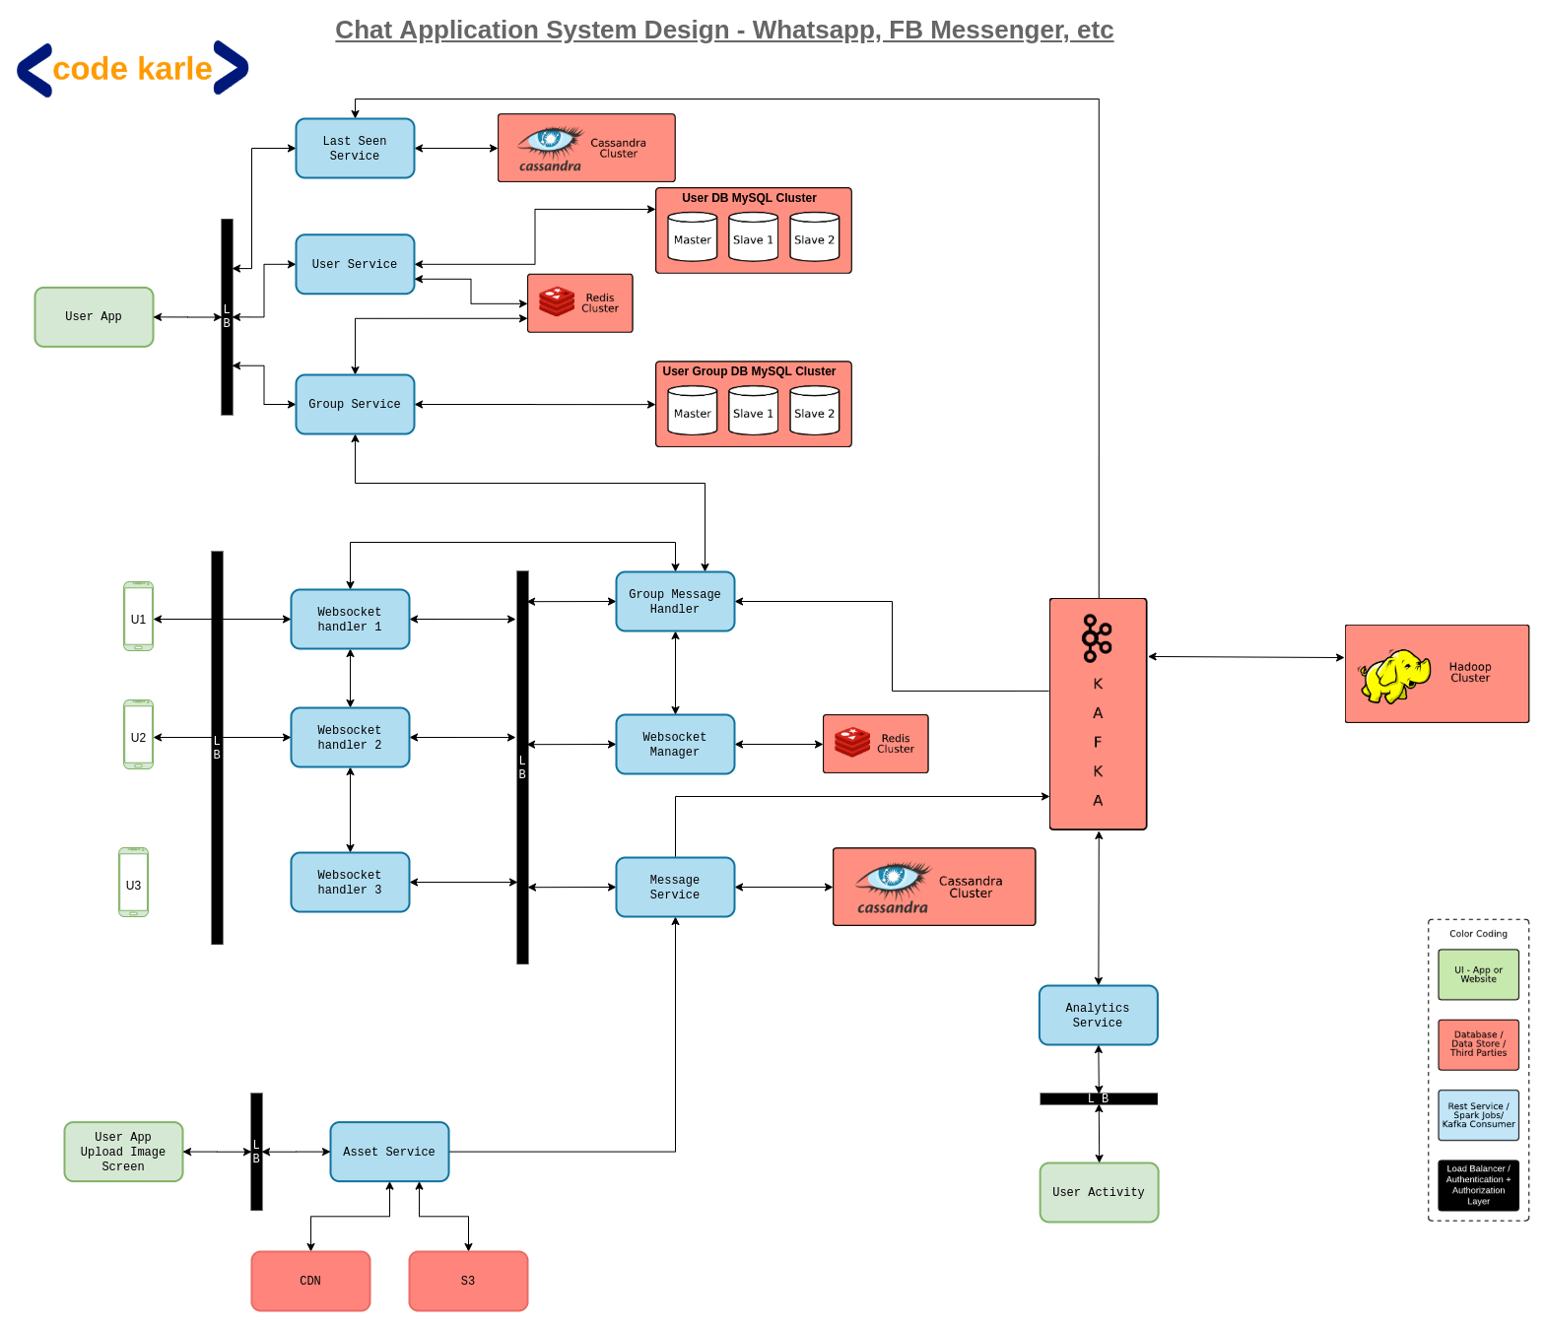

something like a WhatsApp or a Facebook Messenger
or any other messenger of that sort.
Now, let's look at some functional and
non-functional requirements that this platform needs to support.
We will support a One-to-One Chat wherein a person can send a message to another person or a user.
There would be something called a Group Chat where
somebody could make a group of people and whenever anybody in the group
sends a message to the group, that message is received by everybody in the group.
The messages could contain text, it could contain images, it could contain videos
and then it could extend to other kind of documents as well.
There is something called Read Receipt, which is basically the single tick when
the message is sent,
double tick when the message is delivered to the
user and a blue tick when the person sees the message.
We'll also show Last Seen time of a particular user.
Coming to the non-functional requirements,
this platform needs to have a very very low latency because
for a chat application it needs to look very real-time so,
while you are sending a message, the other person should immediately be able to see that message.
And obviously it should have a very high availability. This system
should not go down, no matter what happens.
Also, there should not be any lag.
In other videos that we have talked about in the past,
we were able to live with a lot of lag as well.
But in this video, we cannot have a lag because again, it needs to be a very real-time system
wherein I am typing something to you and you can see it then and there and then respond to it.
Coming to some scale numbers, these are approximate numbers of WhatsApp.
Again, I do not know if these are actually correct or not but I just read somewhere.
WhatsApp has roughly 2 billion users, out of which 1.6 billion users access
it on a monthly basis. These are unique users.
Each day WhatsApp has somewhere close to 65 billion messages being sent across all the users.
And that's a very big number.
We will try to look at how can we design a system
that can deliver all of these functional requirements, with a very low latency
and can live with these kind of numbers.
Numbers for Facebook Messenger are approximately similar
and other chat application could also be running at a very same scale.
Let's look at the overall architecture of the whole system.
We'll first start with the Chatting Solution and then
we'll look at other small pieces that surround it.
Let's start with the User flow.
All of these things that you see here are basically user devices.
Could be mobile phones, could be web browsers,
could be wearable devices like smart watch and all of that.
Let's say user1 wants to send a message to user2.
So, the flow goes like this -
user1 wants to send a message to user2 with a message id, m1.
What happens is - user1 is talking to something called a WebSocket Handler 1.
There will be a lot of these WebSocket Handlers.
What this is - is basically,
a WebSocket Handler is a server on our backend,
which is keeping open connections with all the active users, right now.
These are the live users, who are having an active internet connection kind of a thing.
All of these users are connected to some of the machines.
Then, there'll be a lot of these machines.
And, all of these would be distributed across the globe.
So that, people in certain geography,
talk to the servers which are nearer to them, so as to have a lesser latency.
Let's just say, user1 is connected
to this WebSocket Handler 1 and it sends this message to WebSocket Handler 1 saying,
send this message m1 to user U2.
Now, this WebSocket Handler does 2 - 3 things when this happens.
It talks to something called a WebSocket Manager.
WebSocket Manager is a repository of the fact that, which device is connected to what all users.
Because these are probably thousands of devices,
we need to keep that information at some central place,
which is this WebSocket Manager Service.
It sits on top of a Redis, which stores two information mainly.
First of all, it stores that user1 is connected to WebSocket Handler 1
and WebSocket Handler 1 is connected to user1, user10, user20, something of that sort.
So, a list of user ids that a particular machine is connected to,
that information gets stored in Redis.
Let's say, a connection breaks between a user and a machine.
And now, the user is connected to a different machine.
So, that information is updated through this WebSocket Manager, into this Redis.
The second thing that WebSocket Handler 1 does is - talk to something called Message Service.
Message Service is basically the repository of all the messages in the system.
It will have APIs to get a message by message id, get the message by user ids and various filters.
So, if you want to fetch all the unread messages
by a particular user and all of that, that would be powered by this Message Service.
It sits on top of a Cassandra database.
Why Cassandra? Because, again we have these billions of users,
who will send many many billions of messages so,
Cassandra is a fairly good data store to store that kind of a volume.
Plus, the query pattern that we have fairly aligns with the query pattern that Cassandra is good at.
So that's the reason we choose a Cassandra here.
There are two kinds of message services that we can build.
Basically there are two kind of messaging platforms that we have.
One is something like a Facebook, which stores all of your messages. So,
in that case everything would be stored in a Cassandra permanently.
And, then there is something like a WhatsApp,
which stores the messages only till the time it is not delivered to the user.
Once it gets a delivery acknowledgement, then it deletes the message.
So, if we want to build a WhatsApp kind of system, we could delete the message from here also.
Deletes are a bit inefficient in Cassandra so, if we were to
build that kind of a system, we might choose some other data store as well.
But for now, Cassandra would work fairly fine.
Coming back to.. we were at WebSocket Handler 1,
which got this message saying U1 wants to send to U2, a message m1.
Talk to both of these services and it would happen parallelly so, it can happen in any order.
Message Service would save the message into Cassandra and give the message id.
Let's say message id is m1.
WebSocket Manager will now tell WebSocket Handler 1,
saying, user U2 is connected to this WebSocket Handler 2.
Now, do whatever you want to do.
Now, this guy, WebSocket Handler 1
will talk to WebSocket Handler 2 saying that I have got a message for U2.
I believe that guy's connected to you. Go send them that message.
Now, there are 2 - 3 possibilities.
WebSocket Handler 2 could actually be connected to that user still and he will send the message.
Or it could not be connected. It will say that I am not connected to the user. The
person has probably gone offline.
So, he will not do anything and the flow ends there.
Let's say, the WebSocket Handler 2 sends this message to U2.
Now there are 2 - 3 things that can happen.
Maybe the user is not using the app actively but the message got delivered.
So, this device will send a message to WebSocket Handler 2,
saying that I have received the message.
Or the second option could be - the person is actually open on the chat
of this user U1 and could see the message then and there.
So, that device would send a message saying, I have received and seen the message m1.
Now, this guy, WebSocket Handler 2 again queries WebSocket Manager,
saying that this message was now either delivered or read.
I need to inform user U1 so tell me which machine is talking to user U1.
It will get this particular machine's IP, saying this guy is now handling
user U1 and it will send this message to WebSocket Handler 1,
saying this particular message id m1, has now been read or received, whatever
and go inform the user and this will be informed to the user.
How are these connections happening?
These are WebSocket connections, which is basically a bi-directional connection.
So, there's no client and server here.
Any party can send a message. So, that's how even server is able to send a message to the client.
These are built on top of TCP.
In this whole process, we queried WebSocket Manager a lot of times.
User U1 calling for U2, U2 calling for U1 and all of that.
Now, at the same time, if the user sends multiple messages, again, we'll try to do that.
Let's try to cache this information somewhere.
Each machine will cache 2 kinds of things.
One it will cache is - the list of users that are connected to itself.
So, if user U2 was also connected to the same machine,
it would have the data in memory. It would never have to call this manager.
The other thing is - it would temporarily,
for a very short duration of time, maybe 10, 20, 30 seconds,
cache the information about conversations that it has had recently.
So, if user U2 was connected to this handler H2,
this guy (H1) will keep it in cache, saying user U2 is on this particular machine.
Because if U1 sends another message to this U2, it now need not call this WebSocket Manager.
But, keep in mind, this second cache needs to
be stored with a very low time to live (TTL) and it should expire every 30 odd seconds.
Because remember, these are global users.
Let's say, if somebody is connecting from Sri Lanka,
you would probably get connected to a server in India.
That's a fairly large amount of distance and that communication might break in between
and the person might get connected to a different machine, the next time.
So to, kind of, handle those things easily, we'll keep this cache at a very low TTL.
There are another set of things.
Now, the receipts that we have sent to user U1 and user U2,
all those receipts.. we need to decide whether we want to store them or not.
So if, let's say, we want to store the read receipts also,
we can store that as a, probably, status in Cassandra, in the same table saying,
this particular message has a, to start with, status as sent.
Then it will move to received. Then it will move to read.
We can decide.. you can decide that based
on your conversation with the interviewer, whether you want to store this information
or even whether you want to store the messages in the first place or not.
All of those things are a conversation that you need to have with your interviewer.
But, you still need to store it, for at least some time.
Let's just say that - user U1 sent a message to user U2 and then went offline.
Now, the receipts wouldn't go back.
So at least, for a short duration of time, those read receipts need to be stored in the database
and whenever user U1 comes online, then he'll get that.
Let's just say, user U1 wanted to send a message to user U3.
So, a second message.. user U1 is sending a message
to user U3, which is some message m2, with some text.
Now, what will happen is -
again, it will store in, through Message Service,
it will call WebSocket Manager, to get who is the machine which is handling user U3.
User U3 is offline. There is no machine that is talking to user U3.
So now, WebSocket Manager will return a response saying, I don't have a machine.
That flow ends there.
This WebSocket Handler 1 does not inform anybody because there is no machine talking to user U3.
So, the flow breaks there.
Now, when user U3 comes online, let's just say that, user U3 gets connected to this
WebSocket Handler H3.
What this WebSocket Handler does in the very first place is - to query Message Service and ask for -
are there any messages for user U3 that are not in received or read status.
This Message Service will respond back and user U3 will see all those messages.
Then, when, as those messages are being received and read,
those communications will flow back through the same flow
like we discussed earlier.
So, then, these machines will start talking to each other,
for user U3 as well and those receipts, will go on to other users as well.
There is a potential race condition here.
When user U1 was sending a message for user U3,
assume, at the exact same time user U3 came online.
We said these are parallel calls, wherein a person is figuring out the machine
which is being used for user U3 and storing the message.
Let's just say that, the very first thing that happened was - WebSocket
Manager returned that there is no machine that is talking to user U3.
The next thing that happens was - user U3
comes online and queries Message Service, saying that get me all the messages.
The third thing that happens is - it stores into WebSocket Manager that
this machine 3 is handling user U3.
The fourth thing that happens is - this message gets stored into this Message Service.
Now, WebSocket Handler 3 thinks that - it has fetched all the
messages for user U3 and displayed it on the device.
This WebSocket Handler 1 thinks that - user U3 is
offline and I have stored the messages and done my work.
But fundamentally, whatever this message m2 was, that has not been received by this guy (U3).
Because, before that message was stored, this WebSocket Handler 3 retrieved all the messages.
These kind of race conditions could happen when you are doing parallel calls.
There are multiple ways to handle it.
You can either do it
sequentially but that will increase the latencies. So, I'll not recommend that.
What another solution you could possibly do is - this WebSocket
Handler keeps pulling the server once in a while,
saying are there any messages that I still missed. So, all of those messages could be pulled.
But, that would happen at a fairly low frequency and those could be bulk calls, something like -
are there any messages for user U1, U2, U3 to U100 which are in sent status,
for all the active users that this machine is connected to.
And, if it finds any messages, it will send all of those messages as well.
There are certain things that happen on the device itself.
Let's say user U1 was offline. And,
you can still send message onto some user's chat, while you are offline.
So, let's say, U1 sent another message to somebody while it was offline.
So, what would happen is - it will try to connect. Because internet is not there,
it will not be able to connect to any servers.
In that scenario, what will happen.. even, in all other scenarios also..
all the messages would be stored in a local database which is persisted onto the device disk.
Let's say, it's an android application.
It could use any kind of a android database like
a SQLite or anything and store all those messages on the disk.
Now, whenever the device gets the internet connection,
it will pull those messages from a queue kind of a thing or that database
and send those messages. So,
this is how it would be able to handle scenarios where the device was offline.
Now, we have the next thing as group messages. How does that work?
Group messages almost work in a very similar way.
Let's say, another scenario, U1 wanted to send a message to group g1, a message called m3.
What would happen is - in case of groups, the behaviour is slightly different.
This WebSocket Handler wouldn't take care of fanning out to all the groups.
This is a very lightweight service,
which just takes a message from a user and sends it to somebody
or gets a message from somebody and sends it to a user. It doesn't have a lot of logic.
For group messages, what it will do is - it will just send a message to Message Service,
saying user U1 wants to send a message m3 to group g1, store it and do whatever you need to do.
So, this message service will insert that into Cassandra saying the message is stored.
Along with that, what it will also do,
for all the group messages, it will put all of those messages into a Kafka topic saying
there's a group message that I've got, which is this user U1, sending to group g1,
a message m3. Go send it out.
From Kafka, there will be something called a Group Message Handler.
This is basically a Kafka consumer, which is listening on to the same topic
and it is responsible for sending out all the group messages.
First of all, it does some validations that it needs to, assuming that's out of scope for us,
saying whether U1 is even in the group to be able to send it to g1,
but assuming that's not a part of scope.
It basically queries Group Service, to get all the users that are into group g1.
It gets a list of users, then it will remove the user U1 from that list.
And now it has a list of the users that are supposed to get this message.
Now, it follows the exact same flow that was used for one -to- one messages
but, for all of these users.
So, it basically calls WebSocket Manager
saying, give me all the machines that these users are connected with.
It will get a response saying machine 1 is connected to user U3; U4; U5,
machine 2 is connected to some other set of users and all of that.
Then it will send the messages to individual machines saying,
to this user send this message, to this user send this message.
And then the receipts and all will follow the exact same flow that was handled earlier.
The next thing - what happens when people are
uploading assets like images or videos or anything of that sort.
The very first thing that happens when you are trying to upload
any content is that - there is some kind of a compression that happens.
Now, in real WhatsApp, there is encryption also that happens right at device
and the encrypted messages are sent out.
And when the messages are received, even the encrypted messages are
received and they're decrypted but we'll keep that out of scope.
We'll just think of some compression there.
Let's say, U3 is sending a image to U2. So, what will happen is - U3 is sending to U2, some image.
This is basically a two-step process.
The first step is - upload an image to a server and get an image id
and then send that image id via the regular route to user U2. And then, U2 can fetch the image.
How the image upload works is - again, these are
lightweight servers they wouldn't have any logic. So, very first thing is -
compression of the image, over here or video or anything. Then,
it will talk to something called this Asset Service.
So, this U3 is talking to Asset Service through this Load Balancer. Again,
all the authentication, authorization will happen at this layer and
Asset Service now gets the whole image or video or whatever.
Asset Service will use Amazon S3 as a data store and it will store all the images there.
Now, based on which image is getting what kind of
hits on S3, it might decide to move some of the images on CDN
and it could also decide to replicate into multiple CDNs or some CDNs,
from where it is getting traffic.
But assuming, it has uploaded the image on S3 and it sends a response saying,
let's say, it is a image i1. It will come as a regular message to U2,
through this WebSocket Handler (H3).. these two WebSocket Handlers saying,
send this message and the receipts will happen in the same way that we talked about earlier.
There could be one optimization that can happen.
Let's say, there's a political event or a sports event
and a lot of people are sharing the same image for some reason.
Do we need to upload the same image multiple times,
if five people are uploading the same image? Probably not!!
So, before it even uploads to Asset Service, the first thing that the device will do is -
take a hash of those images and send the hash content to Asset Service.
Basically, it's a way of asking - do you have this image already or not?
If you have it, then just send it to user U2.
If you don't have it, then ask me and I'll upload it. Something of that sort.
Of course, when it's about hashing,
there would be various problems like duplicate hash outputs and collisions and all of that.
So, instead of taking one hash, we could probably take five different
hash algorithms and use all of them to get five different hashes
and if all the five hashes are matching against an image,
then we'll say that, an image is already there.
If it's not matching, then we'll say that, the image needs to be uploaded
and it will follow the regular route that we talked about.
And if it is already there, then anyway it's there, it just sends a message.
Now, let's look at remaining few components and how they help in the whole system.
So, this is the user app, which talks to all of these components. It could be a browser as well.
The very first thing is - something called User Service. This is basically a
service, which owns the user profile information.
It could be - their name, their user id,
their profile picture in case of WhatsApp and some user preferences. In case of Facebook, it will be
a larger set of data. But all of that, whatever that data is,
it would be residing in a clustered MySQL, which runs the user database.
All of those information would also be cached in Redis cluster,
very similar to the way we have implemented in other similar solutions.
Against a key, we'll be having the user
profile information and a lot of other information as well.
There's something called Group Service, which basically maintains all the group information.
It basically has information of - which group has what all users.
Think of it as a many-to-many table, with a user id and a group id
and a time when user was added into the group
and maybe a status saying, whether the user is admin or something of that sort.
Again, this information would be stored in the MySQL cluster,
which would be geographically distributed and it will have multiple slaves
through which the read queries will be run. It will also have a Redis sitting on top of it. So,
all the APIs like, let's say, get users in a group
and something of that sort,
would be powered by this Redis cluster and those APIs would be sitting within the Group Service.
Each time, either User Service or Group Service, queries Redis and it does not find the data,
is when they actually query one of the salves
of these databases, fetch the information, put it into the Redis and respond back to
whoever is calling them.
And then, group service was used in the group messaging workflow, that we looked at earlier.
Each action that a user is taking on their app, gives us a lot of information.
For example, if a person is visiting some user's profile a lot of times,
that tells us that the person is interested in this user.
It could be used for some kind of Analytics.
Let's say, if a particular person is talking a lot about sports,
that does tell us that the person is a sports enthusiast.
How could we do that?
All events that are happening,
either they are events within the app or they are messages or anything of that sort,
would be sent either to this Analytics Service and then to Kafka,
or directly to Kafka, in case of messages.
There could be a Spark Streaming Consumer running on top of this,
which could do a lot of inferences.
First of all, it could do some message classification into some tags,
like a message is a sports kind of a message or a general message or a
politics kind of a message and then try to classify users basis that. So,
that is one kind of analytics.
Another thing could be, just simply,
some information about what are people talking about, in general.
This is not possible if the messages are end to end encrypted.
But if that's not the case, then we should be easily able to infer all of that.
There are two parts.
One is - doing some logic, based on some streaming content.
That could be done by a simple Spark Streaming Consumer.
And, that consumer would also put that data into Hadoop.
And then, you can run a lot of analytics queries, based on Hadoop.
Something like, which are the people who talk about sports a lot or which
are the people who just talk about a particular kind of political party or
anything of that sort. Those kind of analytics could be run out of that Hadoop cluster.
These events are also having one more usage.
Each time a person does an activity on the app,
those events are listened by something called Last Seen Service.
This Last Seen Service is basically, the service used to store the last seen time of a user.
This service.. I made it to sit on top of a Cassandra database,
which has a column called user_id and a column called last_seen_time.
This could also alternatively sit on top of a Redis, if you have finite amount of data.
But along with last seen time, if you want to store certain other information,
then Redis might have memory issues.
So, in that scenario, you can use a Cassandra.
You might have a doubt that - when we use MySQL for user information,
why don't we use a MySQL here? The reason is -
let's say, a user is on the app.
Every five seconds, the app will send a notification that the user is live.
So, every five seconds, for each user, this will have a
insert into the database. What that means is - this is having an extremely high throughput
and MySQL might not be able to support that because these are all the writes,
which will go into the master node of MySQL.
But, if it's a Cassandra, it could be spread out easily across a lot of users.
Redis might also have those update problem because
for all the users, you are doing a lot of inserts. So, Redis might not be able to scale.
But, if it's a Cassandra, it should easily be able to scale to any amount of traffic,
any amount of users and those things coming at any frequency.
One more thing - There are two kinds of events that are spawned.
One are the events that are spawned by the app and one are the events that are spawned by the users.
Example of events spawn by app could be - as soon as you turn the internet on,
the app would make a WebSocket connection
and pull in some requests. That is not a user activity. So,
that would not be captured as a, you know, activity of a user in the Last Seen Service.
But, as soon as the person opens the app or closes the app
or does anything within the context of an app,
those are actually the events that Last Seen Service would be looking at.
In general, all the services that we looked at, we are looking at here,
in the other previous section, all of those are, as usual, horizontally scalable.
So, when your number of users or anything increases,
you just add more number of nodes and that should be able to handle itself.
Other than that, you will obviously need to do a lot of monitoring,
alerting - basically to ensure that you are able to get to your NFRs of
no lag, low latency and high availability.
So, some of the important things that you want to,
kind of, keep a track of from a monitoring perspective is -
the CPU memory utilization of your services, your disk utilization in the databases,
your throughputs and latency onto your web services
and the disk utilization in your Kafka and more importantly the lag in Kafka.
Let's say, if your lag increases, you need to add more number of consumers.
So, all of those metrics you can capture, store it into a
Grafana kind of a store and plot some graphs out of it.
And also, you can build some alerting out of it. In case
your numbers go beyond a certain threshold, you can send out alerts.
Those alerts could be used to make some decisions.
For example, if your throughput is increasing significantly,
you could add more machines into a particular service
and in fact those things could be automated as well.
So, if you're using AWS kind of a thing, you might write a script which
looks at your throughput and it adds more nodes or removes certain nodes.
All of those things are very important when it comes to
a chat application because one of your very critical NFR is that it needs to be actually
real time. If it's not real time, then it will give a very
bad experience and then people will kind of drop out of your platform.
So yeah!! That should be it about a chat application.

